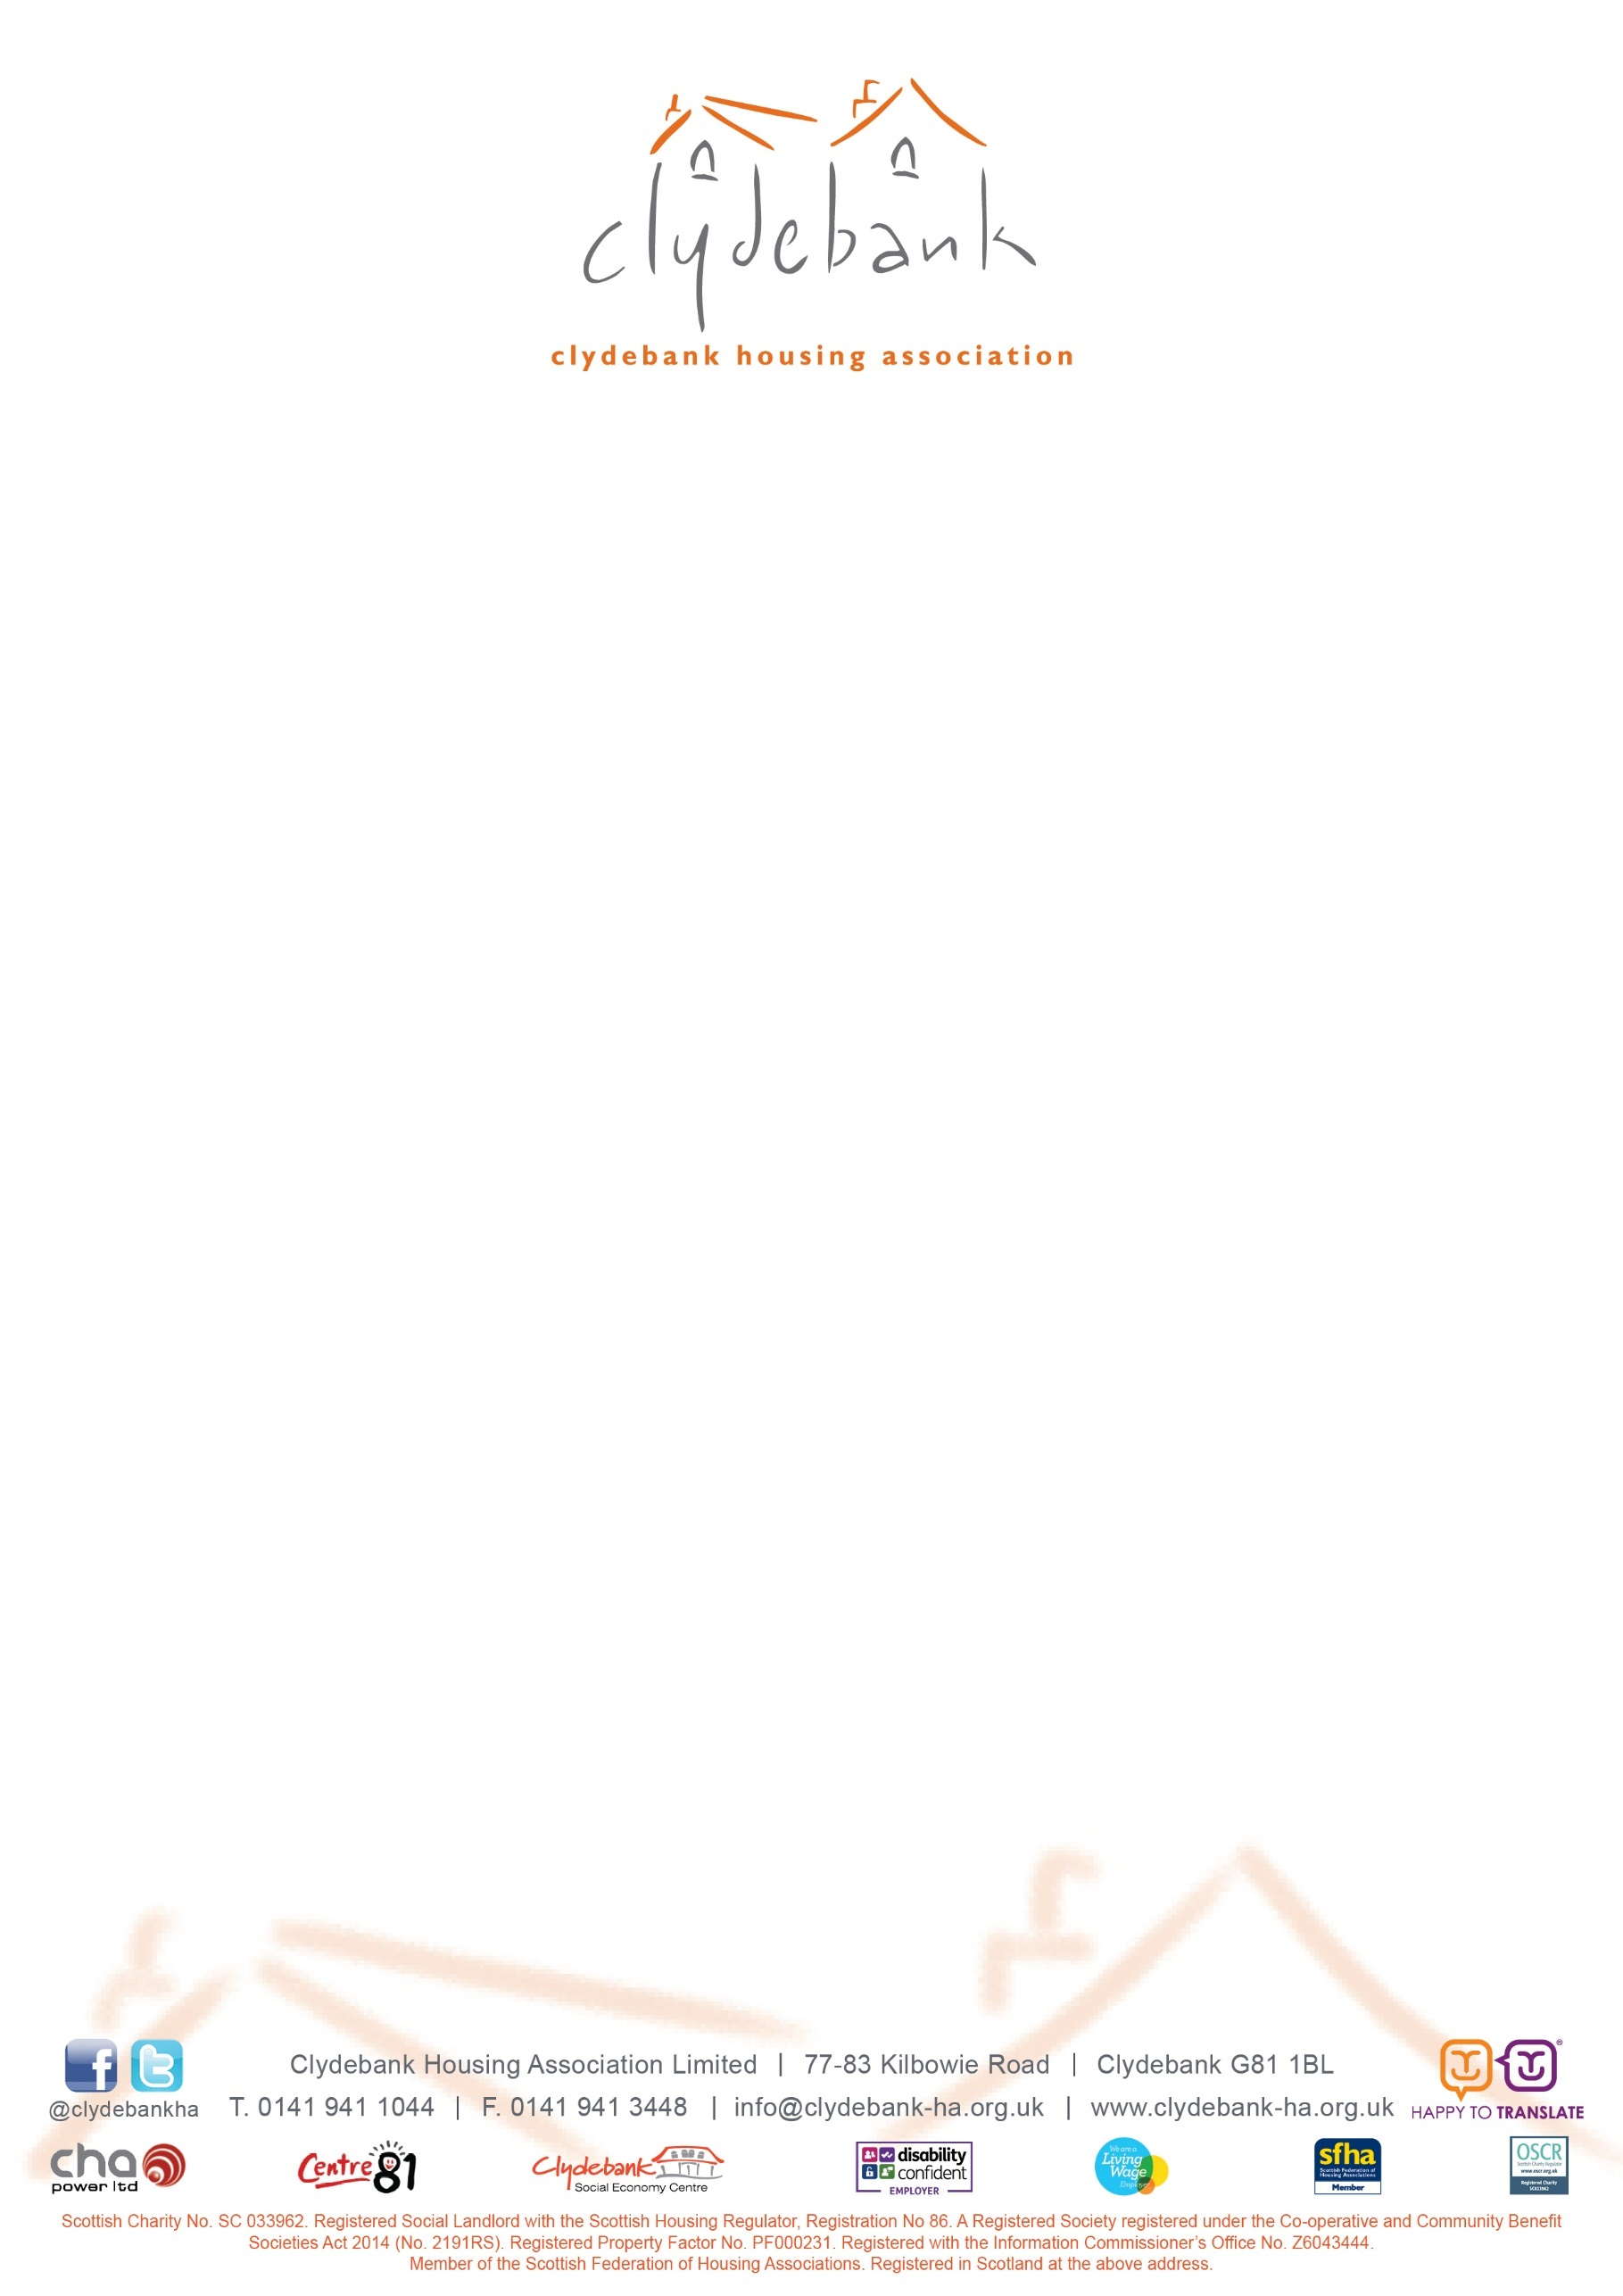

*“Offering our community more than a home”*

Tenant Satisfaction Survey - March 2025

Invitation to Tender

**Clydebank Housing Association Ltd**

**Brief for 40% Tenant Satisfaction Survey - March 2025**

1. **Tender Information**

**Tender title:** Services for Tenant Satisfaction Survey

**Contract start:** 11 February 2025 (date of appointment, subject to successful references where applicable)

**Length of contract:** contract end expected end of April 2025 (on receipt of final survey report)

Tenders are invited for the services of carrying out a Tenant Satisfaction Survey for Clydebank Housing Association Ltd (CHA).

You are invited to submit your tender on the basis that there will be no cost chargeable to CHA for your participation in the tender process.

You are asked to submit your proposal based on the information provided within the tender documentation.

The information included within this document is strictly confidential.

1. **Our Association at a Glance**

* Providing houses in Clydebank, West Dunbartonshire, for over 40 years
* Manage and maintain 1,211 homes for rent, mainly in central and east Clydebank
* Provision of 34 shared ownership properties and factor to over 600 owner occupiers
* Rental income of c. £5.06 million received in year to 31 March 2024
* Run by a Management Committee made up of local volunteers who employ 35 staff
* Assessed as compliant by the Scottish Housing Regulator (March 2024)
* Our Chairperson is Catherine Boyle and our Chief Executive is Lynette Lees
* The Association is a registered non-profit making organisation under the Co-operative and Community Benefit Societies Act 2014 No.2191R(S). The Association is governed under its Rule Book
* The Association is a registered Scottish Charity with the charity number SC033962
* The Association is registered with the Scottish Government as a Registered Property Factor, registration no. PF000231
* The Association is a member of the Scottish Federation of Housing Associations

1. **Preferred Methodology and Timescales for Delivery of Survey**

* 485 tenants to be surveyed face-to-face* (not including unproductive visits)
* Responses gathered for 6 Scottish Social Housing Charter Indicator questions to report to the Scottish Housing Regulator via the Annual Return on the Charter (indicators 1, 2, 5, 7, 13, 25). Open questions for those expressing dissatisfaction on these indicators will be included. Whilst normally indicator 12 would be included (Repairs & Maintenance), this is being collected separately. In place of this we would wish to ask some enhanced equal opportunities questions on some of the protected characteristics to learn more about our community
* Responses gathered around some contextual areas of the key indicators such as communication and participation
* The survey should take 20 minutes or less to complete
* The survey should be set up so as to ensure a sampling error of ±5%
* **Week commencing 17th February:** Clydebank Housing Association will contact all tenants inviting them to participate in the survey. This letter/email will notify tenants that their contact details will be passed to the successful company to allow completion of the survey, however, if they do not wish to participate in the survey and have their details passed on, then they should get in touch with ourselves. If timings permit Clydebank Housing Association will follow this up with a front page March newsletter article with the successful company’s contact details to participate in the survey.
* **By 3rd March:** The successful company will be provided with a comprehensive database of tenants in MS Excel. This will include the following information: tenant name, address, postcode, telephone number, geographical area/estate, property type, property size. This will exclude any tenants who requested to opt out of the survey and will highlight any health and safety matters. The database will be sent password protected and encrypted and should be treated in the strictest confidence by and used only for the purpose of carrying out this tenant satisfaction survey.
* **By 10th March:** The successful company will carry out an analysis of the Association’s tenant base and profile what a ‘representative sample’ will be. This will be used to structure fieldwork. We will be assured that interviews will be achieved spread across all areas of the Association’s stock and will be representative of different tenant groups.
* **10th March – 31st March:** Survey fieldwork will be carried out, working to achieve a 40% response rate from the Association’s tenant base. This will mean achieving 485 interviews of our 1,211 properties. This will include tenants who opted in to the process and a representative sample of the wider tenant base.

Interviews should be carried out on a face-to-face* basis by fully trained and experienced interviewers, operating to the MRS Code of Conduct and ISO20252 accredited policies and procedures. They will carry photographic identification and a letter of authority from the Association when approaching tenants. They will wear face masks when requested to do so unless medically exempt.

Response rates will be maximised by undertaking interviewing at evenings and weekends as well as during the daytime and making a minimum of 4 call backs before classifying as a non-response. Interviewers should be supervised and their achievement and quality of interviews monitored. A percentage of each interviewers work should be validated to ensure quality is consistent.

* **Week commencing 21th April:** Meet with Clydebank Housing Association to review top line survey results, provide follow up contacts and also raw data which will be used for the Association’s Annual Return on the Charter.
* **Week commencing 28th April:** Provide a comprehensive report, with associated tables, charts and narrative, on the tenant satisfaction survey, including details of tenants who have requested follow up contact. Present survey results at a particular forum, to be agreed.

*\* subject to any potential Government restrictions*

**4. The Tender Process**

Each consultant is required to submit the enclosed cost proposal and a supporting letter, including any comments on the preferred methodology and timescales for delivery of the survey. Previous experience of working with registered social landlords has also been requested, where applicable.

Referees will be contacted for the two consultants who top our 60/40 price/quality comparison, should we have no prior satisfactory professional relationship.

Clydebank Housing Association Ltd is an organisation dedicated to providing value for money and social and community benefits. Please provide details of any aspect of your service that you feel will add value to the service that your organisation can provide to Clydebank Housing Association Ltd.

Closing date for tender submissions is **12.00pm** on **Monday 10 February 2025**.

**5. Tender Scoring**

Scoring and weighting will be undertaken on the following basis:

* Provision of required information/documentation
* Sector knowledge & experience
* How well assessed CHA's needs are & how it will meet these needs
* Proposed team
* Survey approach and methodology
* Standard of reporting/sample documents

Feedback on the scoring and weighting will be provided to all those who return a tender.

**6. Payment Terms**

The Association would welcome a payment schedule as follows, or similar - 40% of project fee upon commissioning, 40% upon completion of fieldwork and the final 20% upon provision of the final report. Payment term is within 30 days from receipt of invoice and method of payment is BACS/Faster Payment.

**7. Timetable**

|  |  |
| --- | --- |
| Date of invitation to tender | 20 January 2025 |
| Date of tender return | 10 February 2025 |
| Date of appointment | 11 February 2025 |
| Fieldwork commences | 10 March 2025 |
| Fieldwork completed | 31 March 2025 |
| Top line survey results provided | w/b 21 April 2025 |
| Final survey report provided | w/b 28 April 2025 |

**8. The Successful Consultant**

Prior to commencing any work, the consultant will be required to provide:

* details of their Health & Safety and Equal Opportunities policies
* details of relevant insurance documents
* the names of all interviewers and confirmation that they will carry identification at all times when contacting tenants face-to-face

The contract will be based on this brief, the completed cost proposal and will be supplemented by an exchange of emails/letters.

Sinéad Farrell, Customer & Corporate Services Manager

Clydebank Housing Association Ltd

20 January 2025

[tenders@clydebank-ha.org.uk](mailto:tenders@clydebank-ha.org.uk)