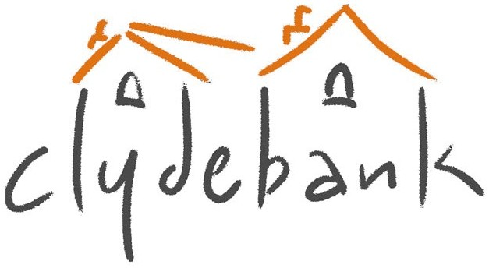
Tenant Satisfaction Survey
2025: Cost Proposal

Company name:
Full company address: |  | Postcode:
Main contact person:
Main contact e-mail:
General contact e-mail:
Contact number(s):
Brief company background (including year established):

Details of previous experience of providing this type of service or similar services to Registered Social Landlords:
Cost (All Inclusive – including all costs and expenses) |  |  | £
40% Tenant Satisfaction Survey (485 no. tenants) cost per the attached brief:

VAT
Total
Name, address and contact details of referee 1:
Name, address and contact details of referee 2:
Declaration of Interest Statement
Entitlements, Benefits & Payments
1. Companies should identify any work they are currently carrying out or competing for which could cause a conflict of interest and indicate how such a conflict would be avoided.

YES / NO (please delete as applicable and provide details below)

2. A declaration of interest must be given where any Director or Manager of a company is a close relative of any staff or Board member of Clydebank Housing Association where any staff or Board member has an interest in the company. This applies to individuals who have been a staff or Board member within the preceding 12 months.

Does any Director or Manager from your firm have such connections with Clydebank Housing Association?

YES / NO (please delete as applicable and provide details below)

Print Name:

Position:

For and on behalf of:
Signed: |  |  | Date:

An electronic copy of the proposal should be emailed to tenders@clydebank-ha.org.uk, by 12.00pm on Monday 10 February 2025

